Learning in An Open World: The Legend of Zelda: Breath of the Wild

Shirley Liu

University of Wisconsin-Madison

Abstract

In this paper, I will use the Legend of Zelda: Breath of the Wild as my topic game. It is an open world action-adventure game jointly developed by Monolith Soft and produced by Nintendo. The protagonist Link wakes up in the underground ruins on Hyrule land, chasing the incredible sounds and embarking on an adventure. I will use Gee’s learning principles manipulation and distributed knowledge and cycle of expertise to demonstrate why Zelda is a good video game and how this game can teach players how to play. Then I will support my thesis by referring the article “Play that can Do Good” and Brown’s book *Videogames and Education*.

*Keywords*: Role-Play Game, Zelda, Open World

Learning in An Open World: The Legend of Zelda:

The earliest electronic role-play game (RPG) was born in the 1970s. The game interface is mostly a collection of numbers and black and white graphics. The numbers are used for description, calculation and determination, and the graphics are used to construct the scene. As a branch of RPG, Action role-playing game (ARPG) belongs to a type of game that amplifies its interactivity. ARPG has unique benefits: fast implementation of interactivity in world behaviors, such as NPC dialogue, convenient sorting and picking items. The Legend of Zelda: Breath of the World (hereinafter called ‘Zelda’) falls into this category. It jointly developed by Nintendo’s planning and production headquarters and its subsidiary Monolith Soft. It was released by Nintendo on March 3, 2017.

The story of Zelda takes place 100 years after the demise of the Kingdom of Hyrule. One hundred years ago, a catastrophe struck the Kingdom of Hyrule. The protagonist Link also fell seriously injured in order to protect the princess, and the Kingdom of Hyrule was destroyed by Calamity Ganon. However, the surviving princess named Zelda released the power of the seal at the last moment and sent the selected knight Link out of the castle, leaving only herself to stand up against Ganon. As the princess alone was not strong enough to destroy him, she finally had to limit herself to the castle together with Ganon. The ultimate goal of the game is to defeat the Calamity Ganon in the castle and rescue the princess.

**James Paul Gee**

James Paul Gee's article on video game learning and how the design can help promote learning is one of the most important references to show how different games teach players how to play. Gee proposed many principles of learning that can be used in video games. Gee believes that a good video game will incorporate many of the principles and successfully achieve these. Zelda also applied many significant principles.

First of all, manipulation and distributed knowledge is an important one. Computer and video games inherently involve action at a (albeit virtual) distance. The more and better a player can manipulate a character, the more the player invests in the game world. Good games offer characters that the player can move intricately, effectively, and easily through the world. Beyond characters, good games offer the player intricate, effective, and easy manipulation of the world’s objects, objects which become tools for carrying out the player’s goals (Gee, 2005, p.8). Today, when the concept of “open world’’ is becoming more and more popular, it is becoming "clear all the markers on the map." The most revolutionary aspect of the open world system of Zelda is that the concept of "open world" has changed from "a limited point-like behavior" to "delimiting a circle." After that, players can do countless things in this plane. One of the biggest characteristics of the open world of Zelda is that an open world means infinite possibilities, and players can do the same thing in different ways.

This world has specific rules. As long as the rules are followed, everything is possible. Players can use metal weapons to "cheat" in the Shrine where player need to use limited metal boxes to conduct puzzles. It can be blown with explosive barrels, smashed with electricity, and a group of Bokblins (one kind of monsters in Zelda) can be crushed to death with stones. This is where Zelda leads and even subverts all the so-called "open world" games on the lowest level of the game system. But the open world, in addition to bringing unparalleled fun to Zelda, there is also an excellent benefit. When players are faced with seemingly impossible tasks, such an open world gives players hope, they will feel difficult, but they will not despair. And they can use wisdom to accomplish the seemingly impossible things. Such an open world undoubtedly gives them courage.

I am a person who is particularly frustrated when playing games, so most of the time, I will choose to drive to the lowest difficulty, fully assisted aiming, and pass a game all the way. But in Zelda, facing the challenges and the seemingly unsolvable difficulties, I did not subconsciously flinch as before, but would find ways to solve it. All of this is inseparable from the possibility of ingenious solutions provided by its open world setting.

In such a world with such a high degree of freedom, how to ensure that players can explore freely without getting too powerful props in the early stage of the game, causing them to lose the fun of the game? The answer to Zelda is weapon durability system plus a combat system with weakened values. This also leads to another Gee (2005)’s learning principle: Cycles of Expertise (p.9). In Zelda, all weapons and equipment except Master Sword are easily destroyed, but most monsters will drop weapons or equipment. During the adventure, player gets weapons from monsters, which brings two advantages. On the one hand, it solves the problem of getting the strongest equipment in the early stage mentioned earlier. On the other hand, it also allows players to see more interactions between weapons of different materials and objects of different materials. For example, sharp but thin weapons can be easily damaged after cutting off trees and carrying metal equipment on back in a thunderstorm can be struck by lightning.

**Adam Eichenbaum, Daphne Bavelier and C. Shawn Green**

Numerous studies have shown that modern video games have instantiated and demonstrated many key principles that psychologists, educators, and neuroscientists believe can enhance learning and brain plasticity. The real-world relevance of the game is important from the very beginning. In this article, the authors mention that creating an environment that encourages users to invest substantial amounts of time in learning and more hours spent on a task means more learning, and video game encourages players to put time in tasks (Eichenbaum, Bavelier &Green, 2008, p.51-52). In Zelda, if the character’s “death” is caused by the player’s operation, then the player’s progress will be reset back to the beginning of the level or some time ago, but the mistake itself will not affect whether the player is finally reaching the ultimate goal of the game. In other words, after players put more time on practicing, as I mentioned before, the character will grow, and the player will gain a sense of accomplishment.

In the real world, the credit system may be the closest concept to the character progression of game design elements. However, the grade point system suddenly turned encouraging students to take courses into dispelling students' enthusiasm for taking courses. Obviously, the most effective strategy is to choose as few courses as possible, and to choose easy courses. In the game, the feeling of "I have upgraded, so I have become stronger" is obvious to the players, but it is difficult for students to feel this kind of positive feedback during the learning process. The only positive feedback in learning may be the sense of accomplishment of getting a high score.

**Harry J. Brown**

In addition, Brown’s book *Videogames and Education* also has great ideas about how good video games as learning machines. Brown (2014) concludes, “adventure games invite the player to inhabit an imaginary world and, in playing the game, ‘to enact an understanding of that world.’ Like riddles, adventure games begin with undiscovered meaning, a locked door, and the dark entrance to a cave. But they do not withhold the key from us. They only require us to search for it, and in order to do so, we must inhabit the world it evokes” (p.31).

There are 120 shrines waiting for solving in Zelda: Breath of The Wild. Each generation of Zelda’s shaping of the game world is almost perfect. In my opinion, each shrine has a different style. Generally speaking, it revolves around one or two specific props as the theme, and has a set of visual designs unique to it. It tests the player’s observation, memory, and familiarity with the layout of the entire maze. Players will be trapped in the maze, and then there will always be such a surprise moment of "I figured out!" When players solve all the puzzles, they will get the final test/reward-the boss facing this maze. After defeating the boss, they walk out of the shrine through the portal and return to the land of Hyrule. All the previous difficulties and depressions disappeared.

According to Brown (2014), he also believes that games promote a learning approach that transcends the boundaries of traditional disciplines and defines comprehensive problem-solving. Electronic games can complement traditional teaching (p.119). The learner plays a leading role in his or her own intellectual development, while the lecturer becomes the facilitator of organizing gameplay and guiding exploration, but there is no strict authorization for the content or learning method of the student. In Zelda, there are many skills like bomb impact launches. This also benefits from Zelda's excellent physics engine.

**Figure 1**

*Bomb Impact Launches*

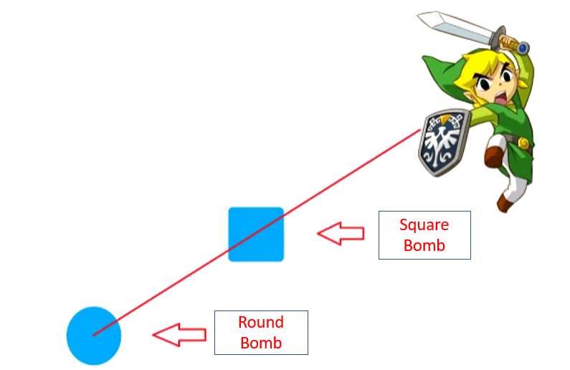

*Note.* Link is on the extension line of the round bomb and the square bomb.

The operation is when two bombs are put down, if the distance and angle is well controlled, only one bomb can be detonated (Figure 1). Then the airflow generated by this round bomb will push the square bomb to touch Link, so that Link is not injured but fast forward. There are many operations like this in the game, which are not taught by the game system, but discovered by the player. It supports Brown's point of view that the learner plays a leading role in their own intellectual development, while the lecturer becomes the facilitator of organizing gameplay and guiding exploration, but there is no strict authorization for the content or learning method of the student.

**Game Redesign**

In the combat system, Zelda does not focus on the attack or defense of player’s equipment itself. Good swords and shields can help players fight, but no matter how good the equipment is, players may never be able to defeat the strongest horse-like lion-faced monster, Lynel, by just swing the weapon in front of it. And a real weapon master, after mastering anti-counterfeiting and perfect evasion, can kill it with a few branches. Most seemingly invincible monsters in Zelda have their own weaknesses, and mastering combat skills is more important than equipment. From this point of view, Zelda’s combat system is simpler than other games of the same kind. The official setting only has a few displacement combos. I hope to add more combat skills for players who want to challenge the limits or pursue gorgeous skills.

There are relatively few large monsters in this game, so that when the player explores the continent, the most challenging monster is Lynel, and it only takes about one minute to end the battle after the player masters the killing method. This will not only make the player lose the freshness of challenging new monsters, but also make the player feel the lack of a combat system. I will redesign this part to diversify the classification of monsters, especially by adding a variety of large monsters, and adding different abilities to them, or increasing the randomness of spawning, so that players do not know what kind of large monster will respawn in this area.

**Conclusion**

The great thing about Zelda's entire series is that, as an RPG game, it weakens all numerically defined abilities to the greatest extent possible. Players do not get experience, level, and various attributes by repeatedly fighting monsters mechanically. The increase in value, not in the process of the game, through the subtle design of the level, a little bit makes players stronger not only in skills, but also in thinking. Players will take advantage of the weaknesses of monsters and the environment. Link’s experience is player’s experience. In the process of transforming from a novice who just woke up from a deep sleep to a hero who saved the entire continent, not just Link, but also plays themself. Game designers can create a world where people can have meaningful new experiences and experience their places of life will never allow them to have experiences that they have never had before. These experiences may make people smarter and more thoughtful. Good games can already do this, and they will be more and more in the future.

**References**

Brown, H. J. (2008). *Videogames and education*. Oxfordshire: Taylor & Francis Group.

<https://doi.org/10.4324/9781315698373>

Eichenbaum, A., Bavelier, D., &Green, C. S. (2014). Video Games: Play That Can Do Serious

Good. *American Journal of Play*, 50-69.

Gee, J. P. (2005). Learning by Design: good video games as learning machines. *E Learning*, 5-

16.

Nintendo EPD. (2017). *The Legend of Zelda* (*Breath of the Wild*) [Nintendo]. Tokyo, Japan:

Nintendo